## PROGRAM DEFINITION

|  |
| --- |
|  |
| * Program batch untuk generate CARE invoice yang belum tergenerate |

## RELATED TABLES

|  |  |
| --- | --- |
|  | **Access** |
| * HDT_TRANS_HD * HDT_TRANS_CHARGES * PMT_TRANS_HD * PMT_TRANS_PD * GSM_PROPERTY | * RW * RW * RW * RW * R |

## ROLES

|  |  |
| --- | --- |
|  | **Test** |
| * User yg mempunyai akses ke program |  |

## INITIAL PROCESS

|  |  |
| --- | --- |
|  | **Test** |
| * Set VAR_COMPANY_ID = Login User’s Company ID * Set VAR_USER_ID = Login User ID * Set VAR_LANGUAGE_ID = Login User’s Language ID * **Get Property List**   Jalankan RSP_GS_GET_PROPERTY_LIST dengan parameter, simpan hasil ke VAR_PROPERTY_LIST dan VAR_SELECTED_PROPERTY   * + VAR_COMPANY_ID   + VAR_LANGUAGE_ID * **Get Property Detail**   Jalankan RSP_GS_GET_PROPERTY_DETAIL dengan parameter, simpan hasil ke VAR_PROPERTY_DETAIL   * + VAR_COMPANY_ID   + VAR_SELECTED_PROPERTY.CPROPERTY_ID |  |

## TAB GENERATE CARE INVOICE

### USER INTERFACE

#### [CR01]

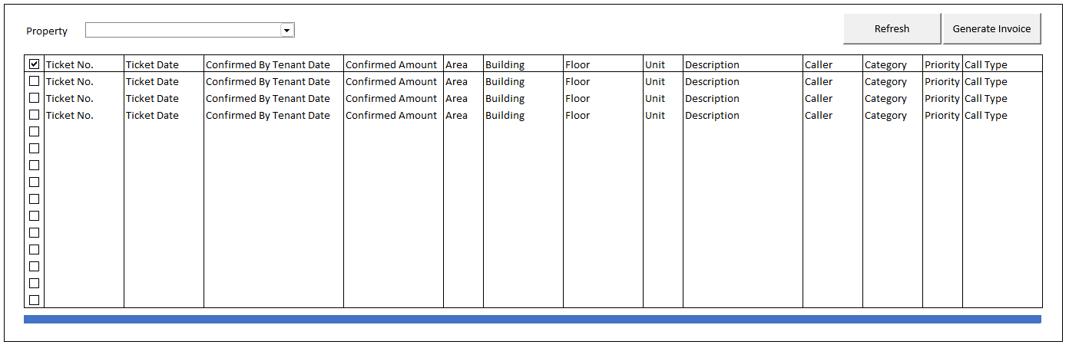

#### INITIAL VERSION

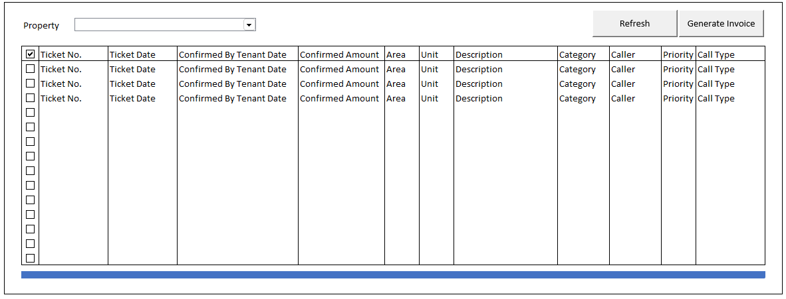

### BUTTON DEFINITION

|  |  |  |
| --- | --- | --- |
| **Button Name** | **Action** | **Enabled** |
| Refresh | Jalankan REFRESH PROCESS |  |
| Generate Invoice | Jalankan GENERATE INVOICE PROCESS |  |

### ROLES

|  |  |
| --- | --- |
|  | **Test** |
| * User yg punya akses ke program |  |

### INITIAL PROCESS

|  |  |
| --- | --- |
|  | **Test** |
| * **Load CARE List**   Jalankan RSP_HD_GET_GENERATE_CARE_INVOICE_LIST dengan parameter, simpan hasil ke VAR_CARE_LIST dan   * + VAR_COMPANY_ID   + VAR_SELECTED_PROPERTY.CPROPERTY_ID   + VAR_LANG_ID |  |

### DISPLAY PROCESS

#### FIELD DEFINITION

|  |  |  |  |
| --- | --- | --- | --- |
| **Name** | **Field** | **Type** | **Validation** |
| Property | VAR_SELECTED_PROPERTY. CPROPERTY_ID | Combobox  Isi combobox dengan RSP_GS_GET_PROPERTY_LIST dengan parameter   * VAR_COMPANY_ID * VAR_USER_ID   Set ValueField = CPROPERTY_ID  Set TextField = CPROPERTY_NAME  Simpan hasil ke VAR_SELECTED_PROPERTY | On Value Changed,  **Load CARE List** Jalankan RSP_HD_GET_GENERATE_CARE_INVOICE_LIST dengan parameter, simpan hasil ke VAR_CARE_LIST dan VAR_SELECTED_CARE:   * + VAR_COMPANY_ID   + VAR_SELECTED_PROPERTY.CPROPERTY_ID   + VAR_SELECTED_CATEGORY   + VAR_LANG_ID |
| **PROGRESS BAR** |  |  |  |
| **CARE Grid** |  | **Data:** VAR_CARE_LIST  **Type**: Batch | Allow: -  View Only |
| Checkbox | LSELECTED | Checkbox |  |
| Ticket No. | CCARE_TICKET_NO | Textbox, Disabled |  |
| Ticket Date. | DCARE_TICKET_DATE | DateTimePicker, Disabled |  |
| Confirmed By Tenant Date | DCONFIRMED_CHARGES_DATE | DateTimePicker, Disabled |  |
| Confirmed Amount  (VAR_PROPERTY_DETAIL. CCURRENCY) | NTOTAL_AMOUNT | NumericTextbox, Disabled | Decimal Places = 2 |
| Area | CAREA_DESCRIPTION | Textbox, Disabled |  |
| Building  **[CR01]** | CBUILDING_ID | Textbox, Disabled | Building  **[CR01]** |
| Floor  **[CR01]** | CFLOOR_ID | Textbox, Disabled |  |
| Unit | CUNIT_LOCATION_ID | Textbox, Disabled |  |
| Description | CCARE_DESCRIPTION | Textbox, Disabled |  |
| ~~Category~~  **[CR01]** | ~~CCALLER_CATEGORY_DESCRIPTION, CCALLER_SUBCATEGORY~~  ~~Set Display:~~  ~~IF CCALLER_SUBCATEGORY is not EMPTY, then~~  ~~CCALLER_CATEGORY_DESCRIPTION (CCALLER_SUBCATEGORY)~~  ~~Else,~~  ~~CCALLER_CATEGORY_DESCRIPTION~~ | ~~Textbox, Disabled~~ |  |
| Caller | CCALLER_NAME | Textbox, Disabled | **Notes: Grid must show at least until this column** |
| Category  **[CR01]** | CCALLER_CATEGORY_DESCRIPTION, CCALLER_SUBCATEGORY  Set Display:  IF CCALLER_SUBCATEGORY is not EMPTY, then  CCALLER_CATEGORY_DESCRIPTION (CCALLER_SUBCATEGORY)  Else,  CCALLER_CATEGORY_DESCRIPTION | Textbox, Disabled |  |
| Priority | CPRIORITY_DESCRIPTION | Textbox, Disabled |  |
| Call Type | CCALL_TYPE_ID | Textbox, Disabled |  |

### REFRESH PROCESS

|  |
| --- |
|  |
| * **Load CARE List**   Jalankan RSP_HD_GET_GENERATE_CARE_INVOICE_LIST dengan parameter, simpan hasil ke VAR_CARE_LIST dan VAR_SELECTED_CARE   * + VAR_COMPANY_ID   + VAR_SELECTED_PROPERTY.CPROPERTY_ID   + VAR_LANG_ID |

### GENERATE INVOICE PROCESS

#### VALIDATION

|  |  |  |
| --- | --- | --- |
| **Field** | **Condition** | **Validation Message** |
| LSELECTED | If no item is selected | Please select at least 1 item! |
|  |  |  |

#### ACTION

|  |
| --- |
|  |
| * **Validate** (See VALIDATION table)   IF Success, jalankan continue process  IF Failed, stay on popup   * Set **Progess bar step** = 4 * Set **VAR_KEY_GUID** = New GUID * Set **VAR_ERROR_COUNT** = 0 * Reset Progress Bar |
| **BEGIN TRANSACTION**   * Buat temporary table   CREATE TABLE #GENERATE_CARE_INVOICE(  NO INT NOT NULL  , CCARE_TICKET_NO VARCHAR(30) NOT NULL  )   * Insert **VAR_CARE_LIST** where **LSELECTED** is **TRUE** into #GENERATE_CARE_INVOICE * **Batch Generate Invoice** * Jalankan RSP_HD_GENERATE_CARE_INVOICE dengan parameter   @CCOMPANY_ID = VAR_COMPANY_ID  @CPROPERTY_ID = PARAM_SELECTED_PROPERTY.CPROPERTY_ID  @CUSER_ID = VAR_USER_ID  @CKEY_GUID = VAR_KEY_GUID  **COMPLETE TRANSACTION** |
| * Refresh **CARE Grid** * IF **VAR_ERROR_COUNT** > 0, show errors |

# CR LIST

|  |  |  |
| --- | --- | --- |
| **CR** | **Description** | **Notes** |
| CR01  NS, 22 Jan 2024 | * Menambahkan Building dan Floor di GRID * Menukar Kolom Caller dan Category |  |